Sabrina DeSoto

Computation in the Physical Sciences

1 November, 2015

**FRINGE RATE MAPPING AT RADIO WAVELENGTHS**

FINAL PROJECT PROPOSAL

INTRODUCTION

Astronomy has long fascinated humans, though the majority of the sky is dark leaving us nothing to see. Compared to visual astronomy, radio astronomy is a relatively new field, which has allowed us to create images of the universe the visual spectrum of light cannot capture (Becker 1995). These images are created by a collection of radio frequencies gathered from an array of antennas. The antennas are spaced at different distances from each other, allowing them to discriminate against background radiation and detect measurements of only certain wavelengths (Ryle 1946). Frequencies picked up by the antennas are passed to a detector and that data creates a catalogue of flux densities from that source (Ryle 1946). These detections appear along the fringe patterns between antennas and depending on the source, if the detection is strong for both polarizations then the sources emissions’ are non-polarized (Briggs 1999). It is expected that by comparing enough detections at certain spots in the fringe pattern between antenna pairs, the celestial coordinates of the source can be confirmed.

Since these arrays are located on earth, the knowledge of their movement with earth’s rotation in relation to the frequencies detected (based on their spacing) can be used to locate the source on the sky (Briggs 1999). This technique, known as fringe rate mapping, requires a reference point to be specified as the center of data collection as shown in Figure 1.

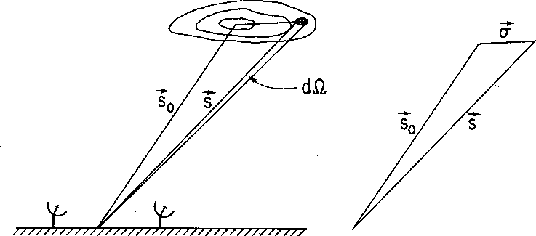

Figure 1. The chosen phase tracking center of the source is described by position vectors in relation to the earth-based antennas. Contour lines represent the source’s radio brightness (Briggs 1999).

From this point the phase changes can be determined for every pair of antennas due to their earth synced rotation (Briggs 1999). Combining this knowledge of the characteristics unique to the emitted radiation’s source allows us to define invisible celestial bodies. This in part answers the question: what else is in space that we cannot see? What is your research question? Your hypothesis?

METHODS

Data for this project is raw data collected from the Low-Frequency Array (LOFAR) and the Westerbork Synthesis Radio Telescope (WSRT) over varying time intervals. The data is restricted to a frequency of 1720 MHz, designed to confirm radio emissions from known MASERS (magnified amplification by stimulated emission of radiation). Phase changes for each pairing will be determined using small time-interval averages calculated from the detection data using Python. The phase of the time-averaged spectra and changing coordinates of the antenna baselines relative to the celestial reference point will also be calculated in Python and used to estimate the source location on the sky (Briggs 1999).

OUTCOMES

The final product of this project will be the coordinates of MASER(s) responsible for the radio emissions over the chosen data collection time frame. These points will not only be an accurate condensed interpretation of the many detections recorded but are useful by noting of the location of that which is invisible. Many important discoveries of the universe from its matter composition to its large-scale structure have come from comparing data across the electromagnetic radiation spectra not just that in the visible part (Becker 1995). Although the product of this work will only visualize a single? point of the sky, it can be used with other sky maps to analyze larger areas. Additionally it should inspire its viewers to continue data collection in all wavelengths working towards the goal of producing the most comprehensive catalogue of the universe possible.

REFERENCES

Becker, R. H., White, R. L., & Helfand, D. J., 1995, ApJ, 450

Briggs, D. S., Schwab, R. S., & Sramek R. A., 1999, NRAO/NMIMT Lectures

Ryle, M., & Vonberg, D, D., 1946, Nature, 158

It is really important when you are presenting your research to others that you use as little jargon as possible and make your language as clear as possible by defining everything. What I try to do when I write research proposals that I know others from outside my immediate field will be reading it, is that I try to write for my Grandmother. I know that if I can explain it clearly to her, then I can explain it clearly to anyone.